Basic Idea of My Final Assignment
Mengjue Sun
Background Story
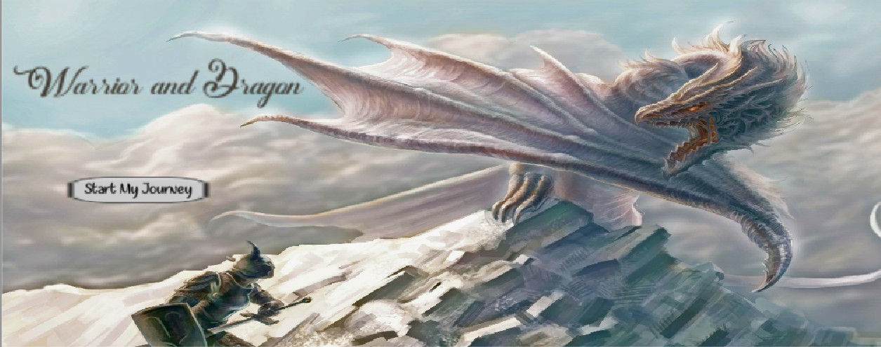
Your main character name is Qiang, he lives in a small village. One day, he just came back from the town but he couldn’t found his finance. In fact, his finance is took by a dragon which lives in the mountain. Qiang found some useful information about how to fight with dragon and demons in an ancient book.
In this journey, Qiang beat many evils, and killed the dragon. However, at the end, Qiang has to choose his ending. There are two rooms in the end: his finance is in one room, another is a room which full of golds, crown and power. Different room leads to different end.
Characteristic
- Complete story line
- Philosophy ending (crown and power ending)
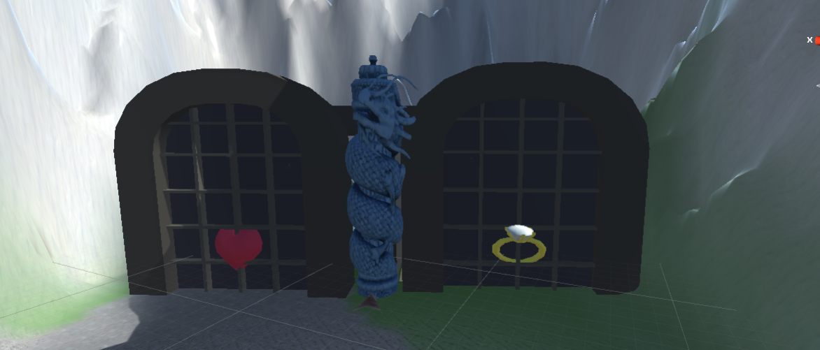
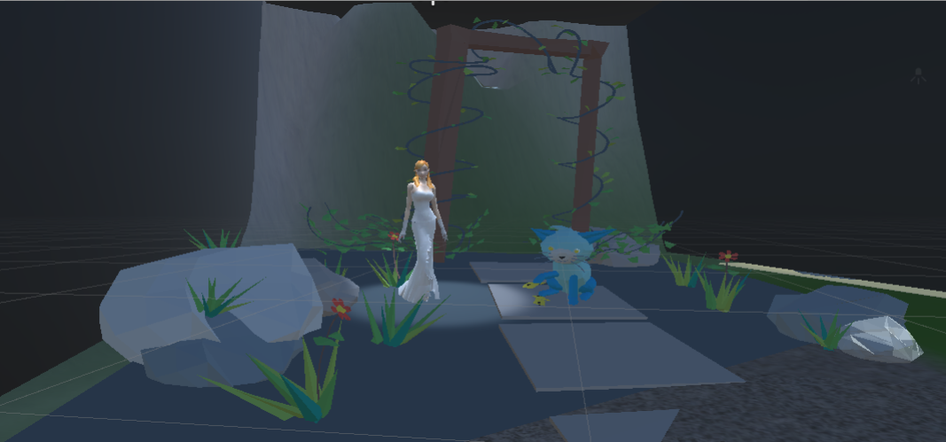
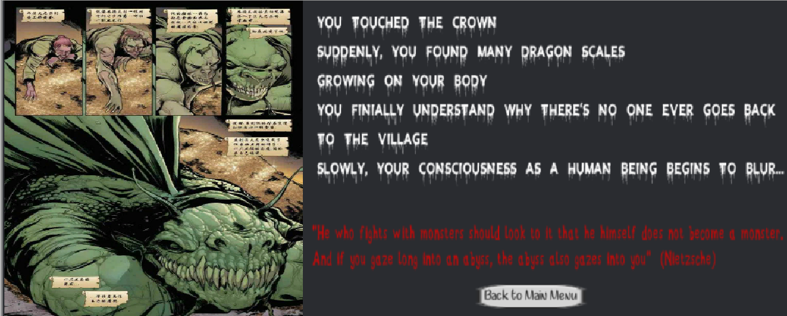
- Traps while playing
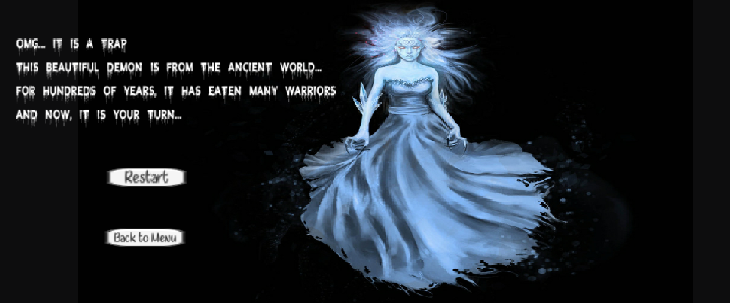
- Special to kill the dragon (climb to the top of the stairs, then shoot dragon head)
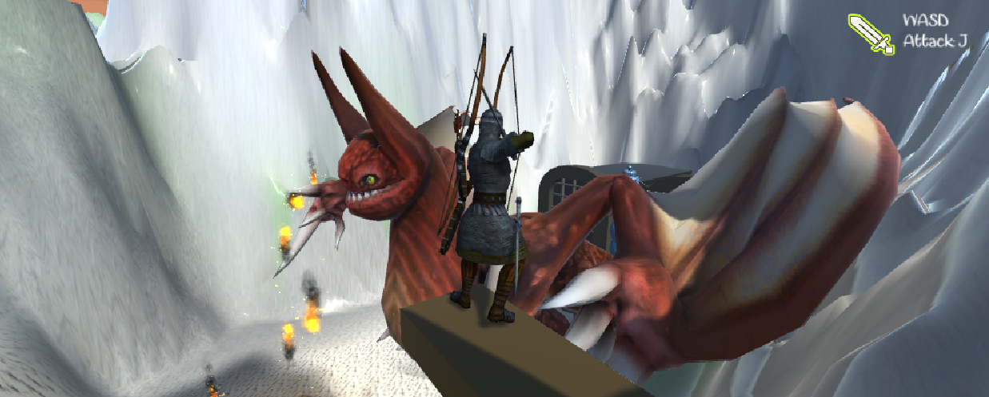
- Maze-like terrain
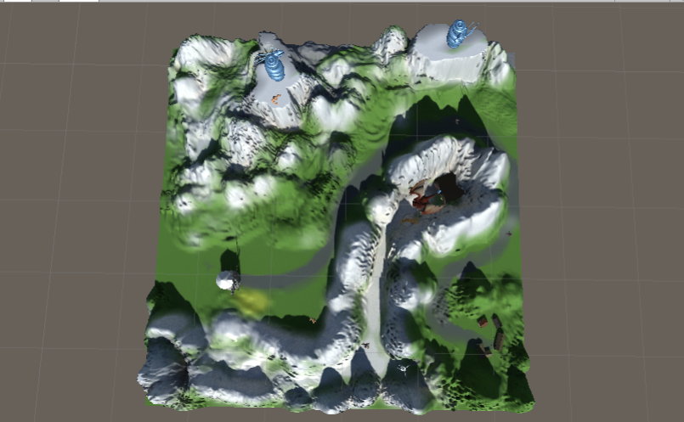
Basic Elements
- Terrain: grass, mountains and snow
- Player: Qiang (the archer)
- NPC: Uncle & Ancient book
- Different death scenes: Killed by demons, killed by beauty, killed by dragon
- Two ending scenes: Finance & Crown
- Control method: press J to shoot, press ASDW to move the character and camera, press Space to jump
- Particle: Dragon fire

